FOR QUESTION NO :
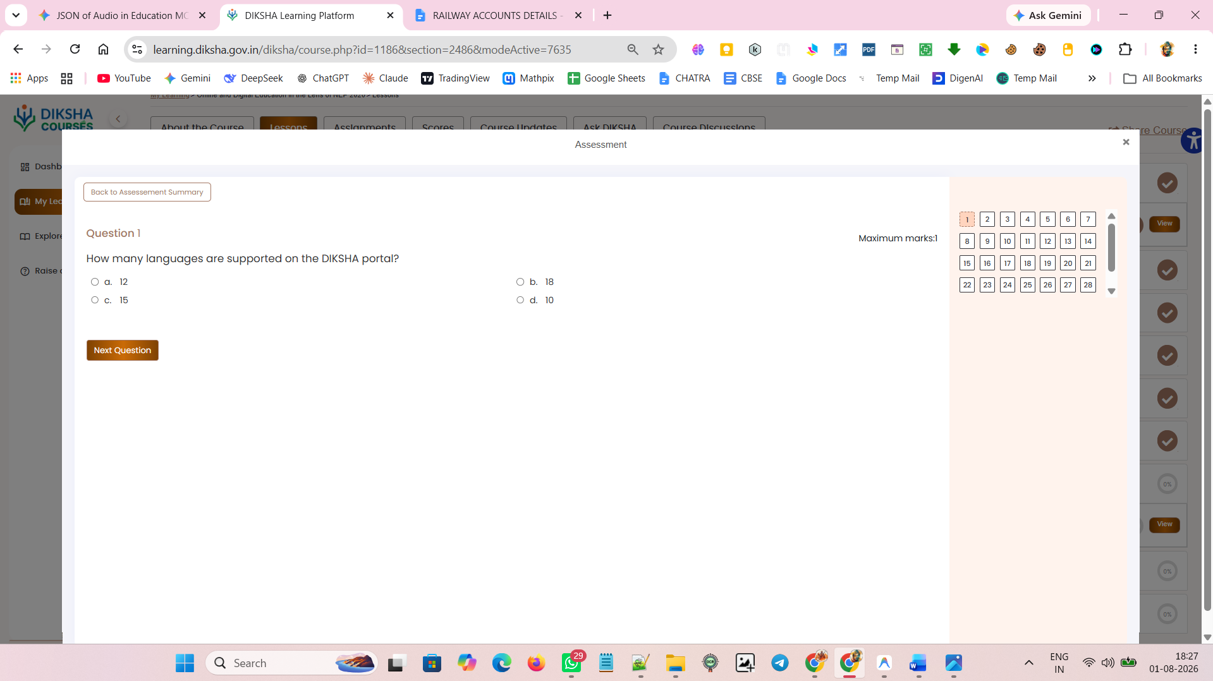

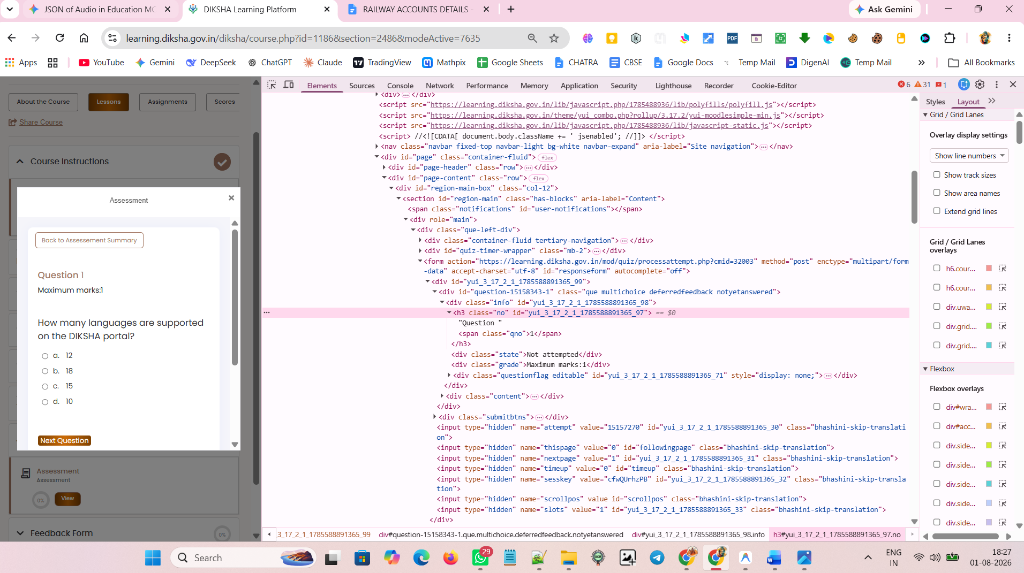

<div class="info" id="yui_3_17_2_1_1785588891365_98"><h3 class="no" id="yui_3_17_2_1_1785588891365_97">Question <span class="qno">1</span></h3><div class="state">Not attempted</div><div class="grade">Maximum marks:1</div><div class="questionflag editable" id="yui_3_17_2_1_1785588891365_71" style="display: none;"><input type="hidden" name="q15158343:1_:flagged" value="0" id="yui_3_17_2_1_1785588891365_27" class="bhashini-skip-translation"><input type="hidden" value="qaid=197247013&amp;qubaid=15158343&amp;qid=77472&amp;slot=1&amp;checksum=3ad8a87e33843daa0fb21a95d96e0c70&amp;sesskey=cfwQUrhzPB&amp;newstate=" class="questionflagpostdata bhashini-skip-translation" id="yui_3_17_2_1_1785588891365_28">
<input type="hidden" class="questionflagvalue bhashini-skip-translation" id="q15158343:1_:flaggedcheckbox" name="q15158343:1_:flagged" value="0"><a tabindex="0" class="aabtn" role="button" aria-pressed="false" aria-label="Flagged" title="Flag this question for future reference"><img class="questionflagimage" src="https://learning.diksha.gov.in/theme/image.php/boost/core/1785488936/i/unflagged" alt="">Flag question</a></div></div>

<h3 class="no" id="yui_3_17_2_1_1785588891365_97">Question <span class="qno">1</span></h3>

FOR QUESTION:

<div class="qtext" id="yui_3_17_2_1_1785588891365_100">How many languages are supported on the DIKSHA portal?</div>

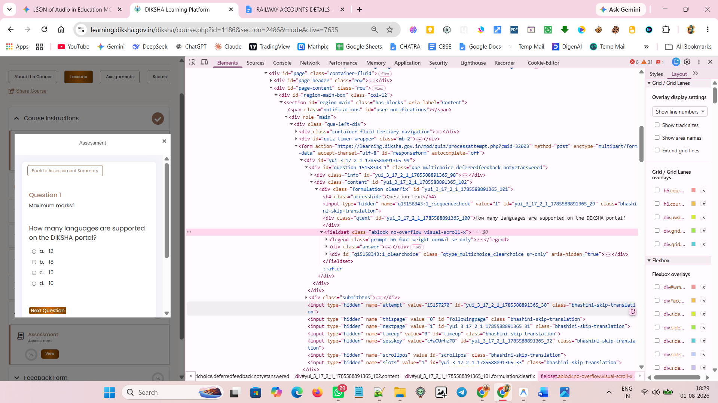

FOR OPTIONS :

<input type="radio" name="q15158343:1_answer" value="0" id="q15158343:1_answer0" aria-labelledby="q15158343:1_answer0_label" class="bhashini-skip-translation" data-initial-value="0">

<div class="r1"><input type="radio" name="q15158343:1_answer" value="1" id="q15158343:1_answer1" aria-labelledby="q15158343:1_answer1_label" class="bhashini-skip-translation"><div class="d-flex w-auto" id="q15158343:1_answer1_label" data-region="answer-label"><span class="answernumber">b. </span><div class="flex-fill ml-1">18</div></div> </div>

<div class="d-flex w-auto" id="q15158343:1_answer1_label" data-region="answer-label"><span class="answernumber">b. </span><div class="flex-fill ml-1">18</div></div>

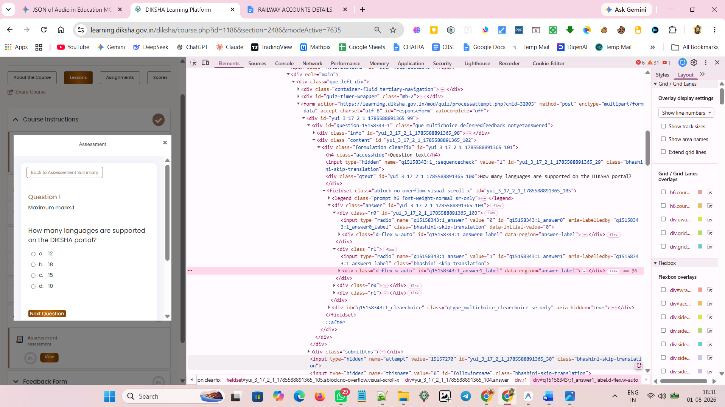

NEXT QUESTIONs

<input type="submit" name="next" value="Next Question" class="mod_quiz-next-nav btn btn-primary bhashini-skip-translation" id="mod_quiz-next-nav" data-initial-value="Next Question">

<div class="submitbtns" id="yui_3_17_2_1_1785588891365_121"><input type="submit" name="next" value="Next Question" class="mod_quiz-next-nav btn btn-primary bhashini-skip-translation" id="mod_quiz-next-nav" data-initial-value="Next Question"></div>

